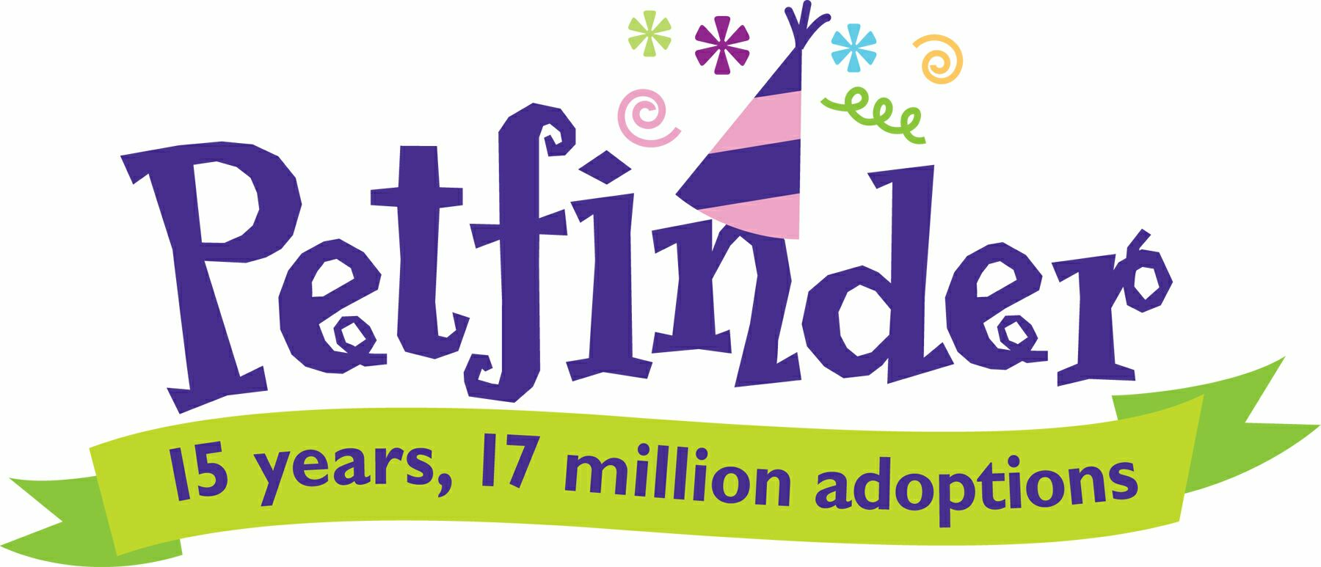

Petfinder Big Birthday Adoption Event
Mega Adoption Event Volunteer Jobs
Welcome/Giveaway Table

Supplies:
- Signage
- Ink pens
- Table(s)
- Chairs
- Volunteer Check-in Roster
- Name tags for volunteers
- Markers
- Box/Container for additional fliers
- Donation jar
- Event Fliers

Welcome:
- Hand fliers/brochures to people as they approach
- Explain our goal is to adopt out 300 animals in 48 hours
- Answer general questions, explain layout of event
- Thank them for coming out!

Giveaways:
- Give new adopters a PetSmart bag and let them pick out whatever they’d like off of the table to fill their bag. One of each item only please.
- Encourage them to go into PetSmart to redeem their coupon book (with $250 worth of coupons in it!)

Checking in Volunteers:
- Find volunteer on check-in sheet, check by name
- Tell them which area to go to
- Give them a name tag with their name to wear

Call ____if you have an urgent problem.

Cat/Kitten Area

Supplies:

- Air Freshener
- Antibacterial gel
- Bowls
- Cage cards with binder clips
- Cardboard carriers
- Cleaner
- Diagram of proper cage set up
- Donation jar
- Event Fliers
- Food
- Food trays
- Gloves
- Ink pens
- Litter
- Litter pans
- Markers
- Paper towels
- Signage
- Slip leashes
- Towels
- Toys
- Trash bags
- Trash can
- Water pail or gallons of water

  - Answering questions for potential adopters
  - Get cats in & out of cages for potential adopters (always use a slip lead)
  - Provide clipboards with adopter surveys for adoption
  - Explain our goal is to adopt out 300 animals in 48 hours
  - Exchange dirty litter boxes for clean ones
  - Load up adopted cats for adopters
  - Refill water & food
  - Take out stinky trash
  - Clean out cages should the cats/kittens spill food, water, etc…
  - Sanitize cages and set up when cats are adopted
  - Thank them for coming out!

Call ____if you have an urgent problem.

Dog/Puppy Area

Supplies:

- Antibacterial gel
- Cage cards with binder clips
- Cardboard carriers
- Cleaner
- Disposable bowls
- Donation jar
- Event Fliers
- Food
- Gloves
- Ink pens
- Markers
- Paper towels
- Poop bags
- Signage
- Slip leashes
- Towels
- Toys
- Trash bags
- Trash can
- Water pail or gallons of water

- Answering questions for potential adopters
- Get dogs in & out of crates for potential adopters (always use a slip lead)
- Provide clipboards with adopter questionnaires for adoption
- Explain our goal is to adopt out 300 animals in 48 hours
- Walk dogs for potty breaks during slow periods or as needed
- Spot clean crates and pick up poop
- Offer water to crated dogs during slow periods or as needed
- Take out stinky trash
- Sanitize crates when dogs are adopted
- Thank them for coming out!

Call ____if you have an urgent problem.

Kid’s Area

Supplies:

Will depend on time of day

- Welcome children and their families to the area
- Share activity options with children and help them find something that interests them
- Assist children who look like they need help with a particular activity and support their creativity
- Encourage children to share their excitement about the potential of adding an animal to their family
- Create a fun, nurturing environment for children while they wait for their parents to make decisions about the animals
- Remind children of the area’s guidelines when necessary
- Hand fliers/brochures to parents as they approach
- Explain our goal is to adopt out 300 animals in 48 hours
- Answer general questions for children and their families
- Thank children and their families!

Call ____if you have an urgent problem.

Adoption Tables

Supplies:

- Adoption Forms/Packets
- Binder clips
- Brochures
- Cash
- Cash box (3)
- Chairs
- Clipboards
- Coolers (for ice & water)
- Credit card machine (2)
- Donation jars
- Emergency kit
- File box
- Antibacterial gel
- Masking tape
- Microchip scanner
- Note pads
- OK Humane stickers
- Paperweights
- Pens
- Permanent Markers
- Recycle box
- Scissors
- Signs
- Slip leashes
- Stapler
- Staples
- Tables
- Trash bags
- Trash cans

- Process adoptions
- Assist the adopter in the paperwork process
- Accept payment
- Answer questions
- Give them the adoption packet for the animal
- Tell them about the giveaway table at the event exit and the coupon book inside PetSmart
- Thank them for coming out!

Call ____if you have an urgent problem.

Adoption Form Escort

Supplies:

- Completed PetSmart Adoption Forms
- Leashes

- Always be near the OK Humane Adoption Table
- Take the completed PetSmart form from the Adoption Table Volunteer
- Walk with the adopter and the new animal inside PetSmart (let them stop at giveaways to pick up their goody bag)
- Stand in line at the register
- Have the cashier scan the appropriate barcode. DOG or CAT
- Give the adopter the coupon book from the register
- Thank them for coming out!
- Return the yellow copy of the PetSmart form to the appropriate rescue table.
- Update the Adoption Counter

Call ____if you have an urgent problem.

